Before starting, please note that the officially supported browsers for the current virtualization software in use are the ones as shown in the figure below
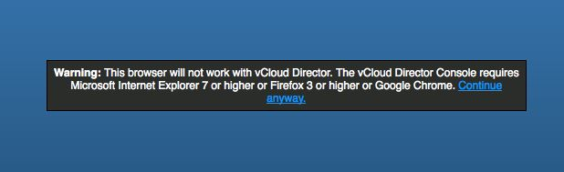
You should be able to access the following login screen at https://vcdcell1.dsv.su.se/cloud/org/lab-vt13/
During your first connection, you will receive a warning message from your browser regarding the trust status of the digital certificate used by the site such as the following for Firefox.
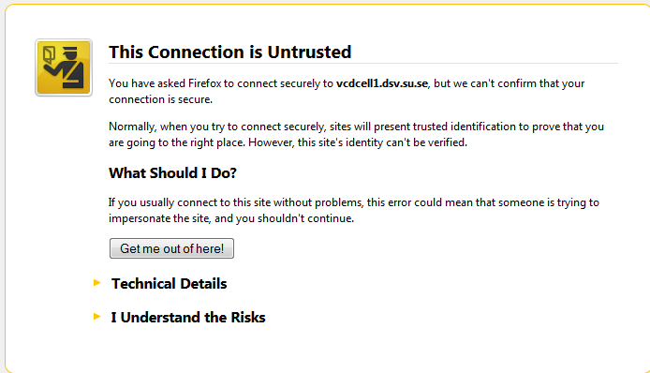
Proceed by expanding the “I understand the Risks” section and clicking on the ‘Add Exception’ option. For security reasons, it’s even better if you verify through the ‘View Certificate’ option that the metadata match the ones below
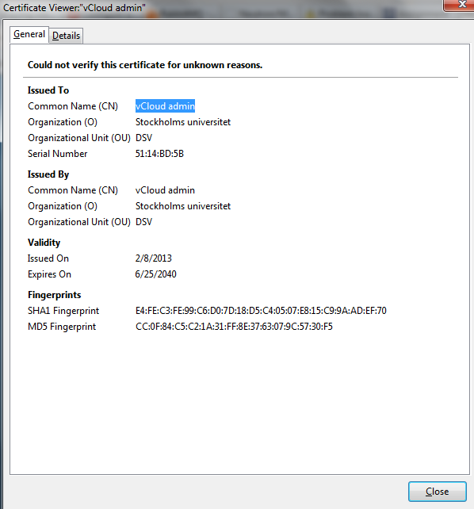
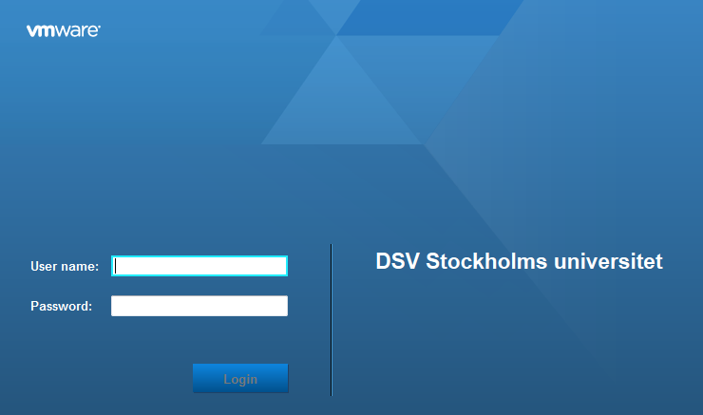
Fill in the credentials you have been given and press the Login button. You are then redirected to the following VM management screen as shown below.
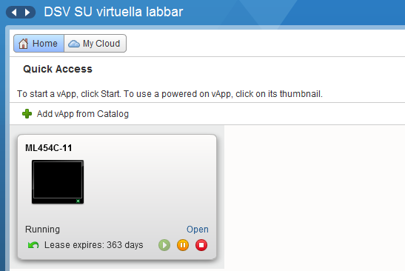
Click on the ‘Open’ hyperlink in order to access your VM as shown below.
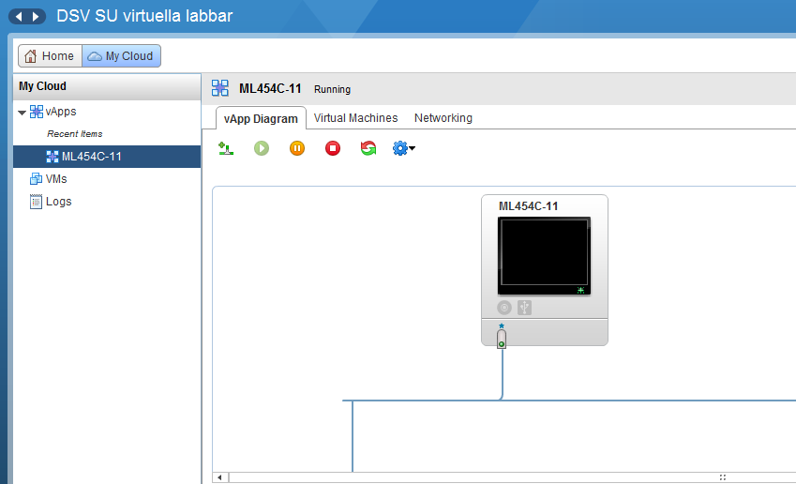
Switch to the Virtual Machines tab.
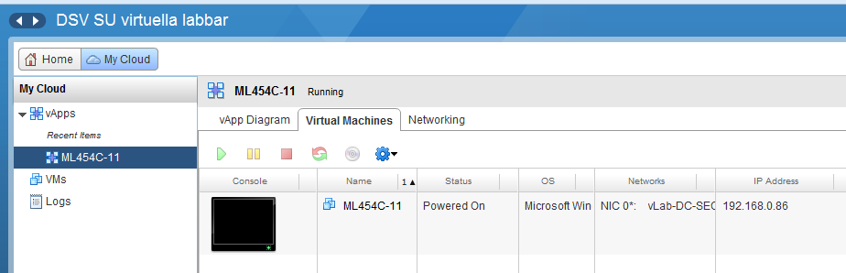
Keep a note of your IP address as shown in the right column and then click on the VM (the thumbnail under the Console column) you want to connect to (you may have to instruct your browser to allow popup windows from vcdcell1.dsv.su.se. In case your VM is not already powered on, you can start by pressing the Play button on the toolbar.
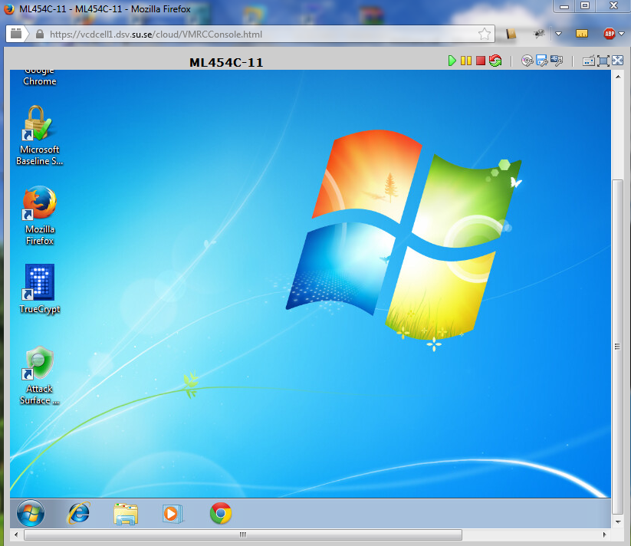
It is a good practice to use the vMenu and select the ‘Create Snapshot’ option before starting using the VMs. In case a VM has problems booting up or becomes inoperable, you can select the ‘Revert to Snapshot’ option.
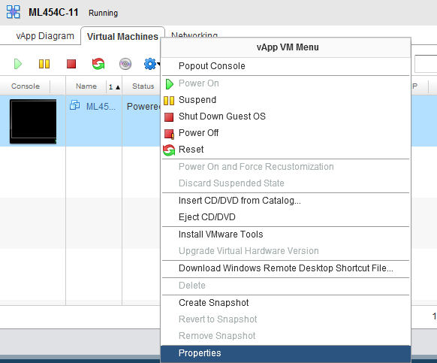
It is good to shut down your VMs (press the) after finishing your work so as to free up resources of the data center.
All the lab actions should be performed via your dedicated VM and not your own system.

